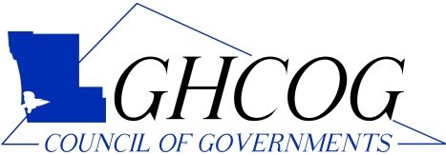

Office Coordinator
Supplemental Material

Based on the following information, draft a professional letter inviting Senator Davis to the Grays Harbor Council of Governments annual meeting.

- Senator Davis, 100 E. Spruce St., Harborville, WA 00000
- Thursday, December 11, 2022 at 7:00pm
- Coastal Convention Center, Suite B, 817 Broadway Plaza, Harborville
- Guest speaker, Alissa Hodges, Governor’s Office on Equity
- RSVP by December 4th
- Send date – three weeks before the event
- Include signature block with your name

